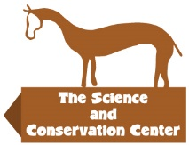
2100 South Shiloh Road, Billings MT 59106 (406) 652-9718 www.sccpzp.org

ON-SITE TRAINING DATES FOR 2024

April 2-4
May 7-9
June 4-6
July 9-11
August 6-8
September 3-5
October 8-10
November – Will schedule if enough interest.

Classes will be added if at least 4 people attend.

Off-Site Training

- Scheduled upon request if associated with a working or up-coming site and at least 6 people in attendance.
- All travel expenses of the trainer, plus an offsite fee will be charged.

Please contact Kayla Grams (406) 652-9718 or kgrams@sccpzp.org

Field Guiding

Need help in the field or just getting started?

Having worked many years with multiple herds and with tractable to elusive horses we can help get you started with documentation and identifying your animals along with guidance in the field as you start to dart horses. All travel expenses of the trainer will be paid for. Please contact Kayla Grams for more information.

